Shepard Academy
Phrases
Writing Sentences with Participial
Phrases
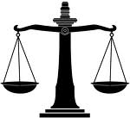

Create a sentence which uses each participle or participle phrase.

Example:
Having won
Having won, my aunt accepted the blue ribbon for her banana bread recipe.

1. hesitating

2. relieved

3. irrated

4. delighted

5. troubled by her decision

6, tired by the journey

7. jogging rapidly

8. overflowing its banks

9. dancing in the streets

10. having been notified

