Shepard Academy
English 11H CC
Law Meets Literature
To Kill a Mockingbird Reader Response Entries
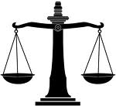

Chapter 1

Chapters 2-3

Chapters 4-6

Chapters 7-8

Chapters 9-11

